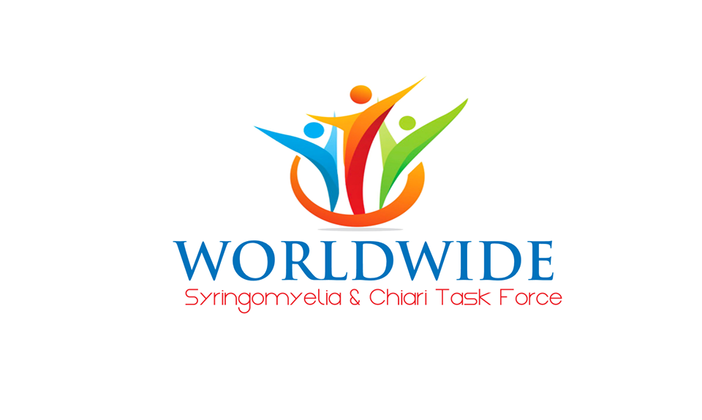

WSCTF DISCLAIMER & PRIVACY POLICY

DISCLAIMER
The Worldwide Syringomyelia & Chiari Task Force (WSCTF) hopes that this website proves to be a valuable tool for patients, nurses, physicians, clinical staff, researchers, the general public and anyone else seeking information about the disease Syringomyelia, Chiari, and their complications.
The content on WSCTF’s website is provided by registered nurses and approved by WSCTF’s medical advisory board. The material is for informational and educational purposes only. It is not intended to substitute as direct medical advice or recommendations on diagnosis or treatment of an individual. Men, women, and children visiting this site should still consult with their treating physician about their medical care. The information found here is not meant as medical advice for any individual. The information here serves as supplementary educational material to aid in understanding Syringomyelia & Chiari across all medical specialties. It serves as a supplement to enhance existing ongoing medical care and encourages collaboration of all necessary medical professionals for the best patient outcome! Syringomyelia and Chiari are complex and require a multidisciplinary approach…at times utilizing several different specialties in medicine. Syringomyelia and Chiari can only be properly diagnosed and managed by skilled and trained medical professionals. The information contained on this site should not replace necessary consultations with the medical professionals responsible for your direct medical care.
Every effort has been made to ensure that the information on this website is accurate and up-to-date. Our Medical Advisory Board reviews and approves all materials for WSCTF. WSCTF makes no guarantees as to the accuracy, completeness, appropriateness or timeliness of such information. In addition, WSCTF accepts no responsibility and disclaims all liability for any decisions made or actions taken based upon material obtained from WSCTF. It is strongly recommended that persons wishing to use information obtained on this website to first consult with their medical provider and/or care team.
PRIVACY POLICY ON PERSONAL & NON-PERSONAL INFORMATION
WSCTF is committed to protecting the privacy of our site users and maintaining the confidentiality of all collected personal information. Personal information on users can be submitted through on-line forms to make a donation, to volunteer, to provide feedback or to register with WSCTF. Access to personal information will be limited to certain WSCTF administrative staff who are required to sign a confidentiality agreement and bound by law.
If you have registered with WSCTF as a member, your personal information, including your contact details and you or your child's medical background, will be safeguarded to the fullest extent of the law. If you have provided your consent, your contact details may be shared with other registered families for networking and support purposes. any identifiable information. No personal information will be released without your prior written consent.
WSCTF may also collect non-personal, aggregated information to tract usage of our website. This includes statistics showing the number of site visitors, requests for particular files on the site, the countries that requests are coming from, sites that users are coming from and going to, and browser and operating systems used. The collection of this information allows us to improve the site's content and scope.

SECURITY
All information described above is stored on restricted database servers. Any personal information obtained will not be sold, rented, traded or released to any third party for commercial use without your permission.

LINKS TO OTHER SITES
WSCTF’s site contains certain links to other websites whose content might be of interest to our site users. WSCTF is not responsible for the material at such linked sites, and presence of such a link does not constitute an endorsement by WSCTF of material on the linked site.

COPYRIGHT
All material contained on this web site is protected by copyright law. No part of this website may be reproduced for commercial purposes without the consent of the Worldwide Syringomyelia & Chiari Task Force (WSCTF). Reprints of site pages may be distributed on a personal basis if proper acknowledgement is made.
Reviewed and Approved by our Board January 1, 2018

